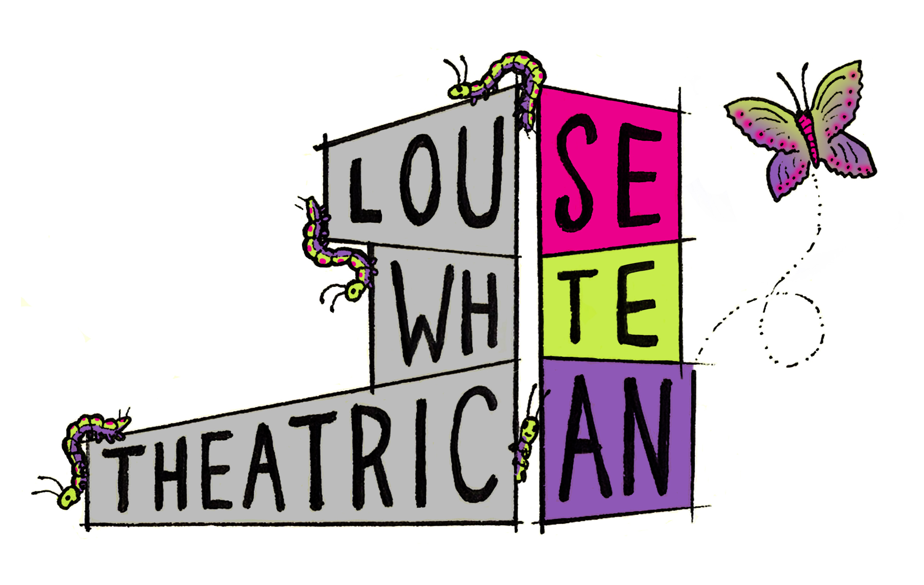
Participant Information Sheet

Who is Louise White?
I am a post-modern performance practitioner and a lecturer. I have developed my artistic practice over the last 10 years working as an associate artist with In Good Company, Curve Breakthrough Artists, and New Perspectives. In this time, I have also developed my pedagogic practice, having taught in various extra-curricular and enrichment settings, and most recently tutoring Levels 2-5 at Nottingham College and Expressions Performing Arts. Alongside this I have developed my academic research; having completed my Masters in Performance in 2020 at Leeds Beckett University. It was during this time that I first pursued in earnest how ‘presence’ is generated in performance in a bid to improve how presence functions within my own practice. And so, this proposed PhD would act as a continuation of that initial research, taking the focus from live to online performance in the wake of the Covid pandemic.

Proposal Summary
I wish to explore the existence and function of presence in online performance. Within the two years, those who do not normally place their practice in online platforms have been given the opportunity to explore moving our performative activities into the digital realm. Although many artists were already working with this medium, an entire artistic community has been in a position where only one medium was available to them in this way. This has led to an online digital revolution where the existence of online connectivity is unlikely to disappear now we are moving back to some sense of normality. But how can presence engage online audiences and tackle alienating those who struggle with remote viewing? What different kinds of presences are available to us, and perhaps exclusively available, with online performance?

Research Questions
The central aims and questions that will guide my research are as follows:

- How can we elicit ‘presence’ in online performance? What are the different kinds of present available to us online?
- What role does presence have in encouraging interactive audiences? How might this affect intellectual and emotional investment in the online performance?
- Can we transcend limits of our computer screens and explore different methods of sharing and inhabiting space between performer and audience? Not limited to visual and oral/aural.
- What is ‘liveness’ in relation to being present in an online arena? I am fascinated by the space/time paradoxes that may arise on the effect of present-ness here, and have explored some notions of this before in my research practice via the digital doubling of recorded self and live self appearing simultaneously.
Themes
Much of my work is autobiographical, and most recently has been enveloped by the idea of what our homes mean to us. During the first lockdown, I moved from my house into my Grandmother’s empty house (she had recently gone into care), in order to keep my parents safe as I continued to work. As we all spent more time at home than we were used too, I began to explore what the home means to us, and in particular what my Grandparents’ home meant to me. Early in 2022 I moved into my very first home with my partner. It is a new-build property and in stark contrast to the Aladdin’s cave of memories and trinkets that my Grandmother’s house was. This is a blank slate. I’d like to see how audiences can help me fill it with memories, and in doing so, explore the possibilities of translating space and time across online platforms and see what presences are available that may connect us in the process.

What is expected of me, the participant?
You will be asked to take part in performance-based online focus groups on a periodical basis. You may be asked to take part in pre-performance activities designed to promote focus and engagement. You may be asked to share stories of your home, or your local area and why they are important and formative to you. We may explore each other’s objects, furniture, artwork that we can see in the background of each other’s’ screens. I have been experimenting with augmented reality technology, so we may have a play with how that can be used to merge our spaces and homes together. I may even ask you to help me decorate my new house! Essentially, due to the nature of the research, I am unable to outline exactly what you will be doing each time we meet – that will depend entirely on how the interim development stages unfold. But the general structure will be that I will share some practical performance explorations (some of which will be interactive) and then there will be a discussion where we can share our thoughts and opinions to a set of structured questions. Whatever happens, you’ll need to come with curious spirit and a playful mind!

How will I be selected?
Once you have contacted Miss White confirming your interest you will be given a consent form to sign. At that point you’re all signed up! As Miss White will only require 5 active participants at a time, she will select these on a first-come-first-serve basis. If you miss out this time, you will be put into a pool of reserve participants and given the opportunity to take part via rotation of active participants or if an active participant withdraws.

How long will I be needed for?
Focus groups will last between 1-2 hours at a time. These focus groups will aim to take place quarterly throughout the year, allowing time in between for Miss White to develop and rework her research based on feedback and outcomes from previous meetings. This may be subject to change, and there may be periods in Miss White’s research that do not require input from participants for a while. Equally there may be more intense periods of work that require participant input more readily. In any case, Miss White will aim to let you know in plenty of time any dates/times that she may require you, and these will often be worked out together to meet everyone’s needs.

But, essentially the answer is, as long as you’d like to be involved for! The PhD is taking place on a part-time basis over 6 years, but you can withdraw at any time if that sounds like too long a commitment for you, or if your circumstances change. There may be several periodic recruitment-drives for participants over the course of the PhD, and if you need to withdraw but would like to take part again at a later date, you’re very welcome to.

How will Miss White get in touch?
Miss White will only ever get in touch outside of focus group meetings via her student email address: l.white4923@student.leedsbeckett.ac.uk. She may need to contact you with details pertaining to dates/times of focus group meetings, and any other relevant information.

Can I withdraw if I need to?
Absolutely. While it would certainly be beneficial to the project to have a consistent participant pool, Miss White understands and appreciates that sometimes life gets in the way, and it is ever more likely to beset us with unexpected changes of circumstances over longer periods of time. If for whatever reason you are no longer able to commit to participating, all you need to do is inform Miss White of this via email. You will be asked if you are happy for Miss White to continue to use the data she has collected from you to inform her research. If you agree to this, Miss White will also ask if you’re happy for her to retain your contact details for future participation opportunities. If the answer to this is no, that’s absolutely fine, and Miss White will ensure that your personal data such as contact details etc are destroyed in accordance with data protection laws.

Is there any remuneration?
This project is not externally funded therefore participation is conducted under a voluntary basis.

Miss White’s Supervisors
If for whatever reason you need to get in touch with Miss White’s academic supervisors at Leeds Becket University, you can contact them via email:
Primary Supervisor – Alex Kelly. a.kelly@leedsbeckett.ac.uk
Supervisor – Adele Senior. a.m.senior@leedsbeckett.ac.uk

